**Contributor name:** Dr.R.RADHA

**Book Proposed:** INTRODUCTORY BUSINESS STATISTICS

**Total Chapters:** 13

**Total Examples:** 174

**Codable Examples:** 118

Chapter 1: Sampling and Data

Example 1.1 – Non-Codable (Reason: Theoretical example with the purpose of proving a concept)

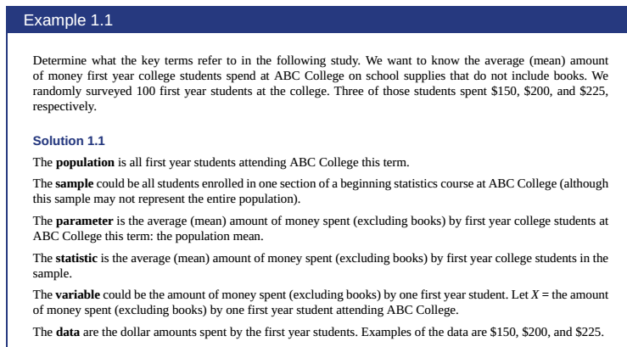

Example 1.2 – Non-Codable (Reason: Theoretical example with the purpose of proving a concept)

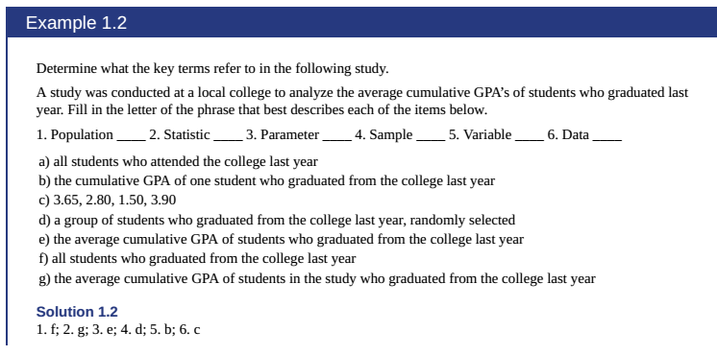

Example 1.3 – Non-Codable (Reason: Theoretical example with the purpose of proving a concept)

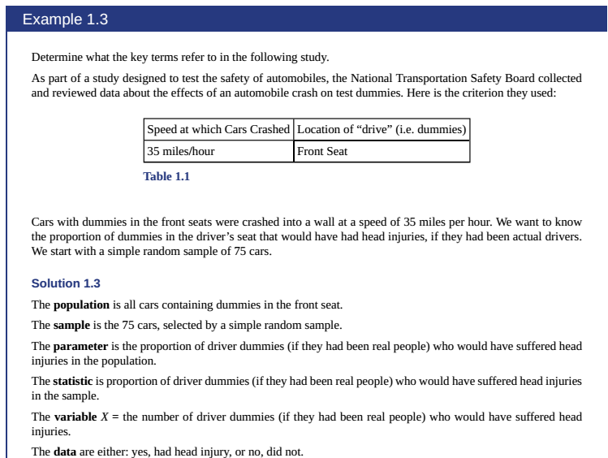

Example 1.4 – Non-Codable (Reason: Theoretical example with the purpose of proving a concept)

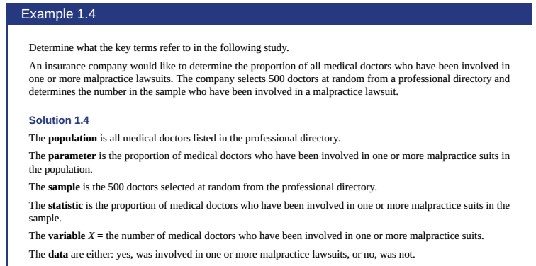

Example 1.5 – Non-Codable (Reason: Theoretical example with the purpose of proving a concept)

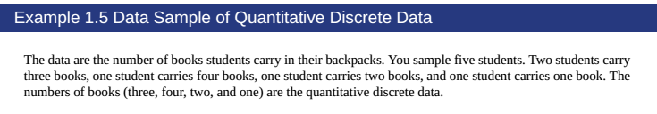Example 1.6 – Non-Codable (Reason: Theoretical example with the purpose of proving a concept)

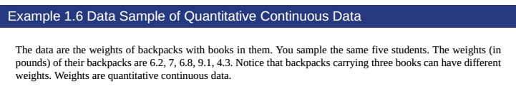Example 1.7 – Non-Codable (Reason: Theoretical example with the purpose of proving a concept)

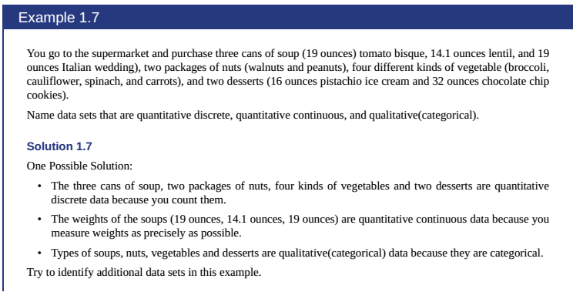

Example 1.8 – Non-Codable (Reason: Theoretical example with the purpose of proving a concept)

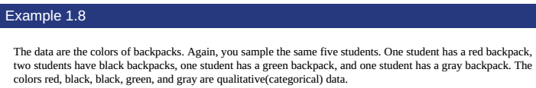

Example 1.9 – Non-Codable (Reason: Theoretical example with the purpose of proving a concept)

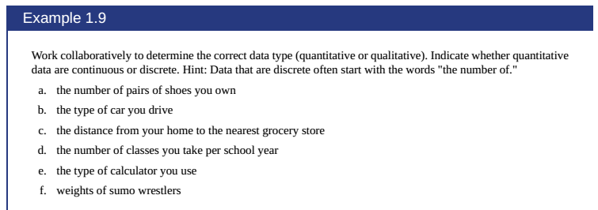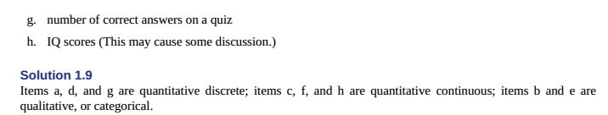

Example 1.10 – Non-Codable (Reason: Theoretical example with the purpose of proving a concept)

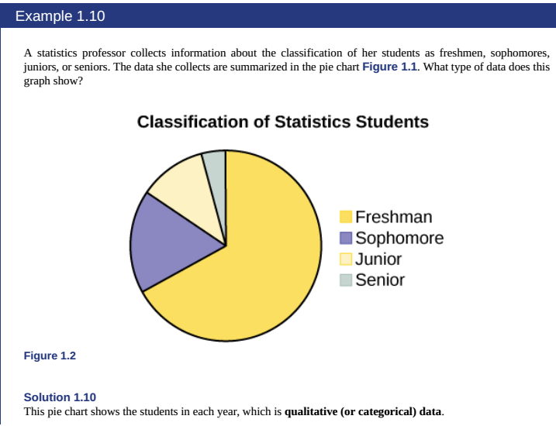

Example 1.11 – Non-Codable (Reason: Theoretical example with the purpose of proving a concept)

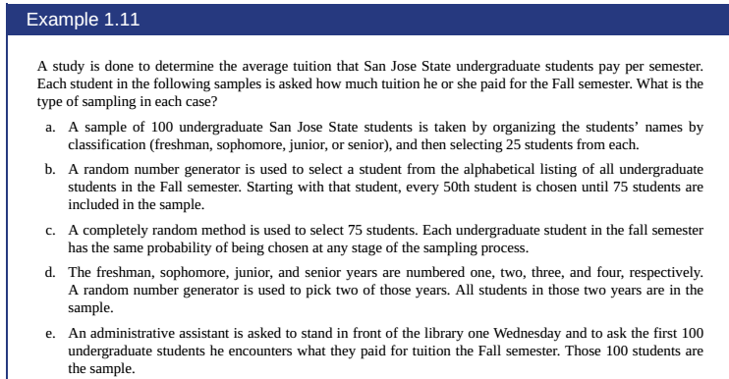

Example 1.12 – Non-Codable (Reason: Theoretical example with the purpose of proving a concept)

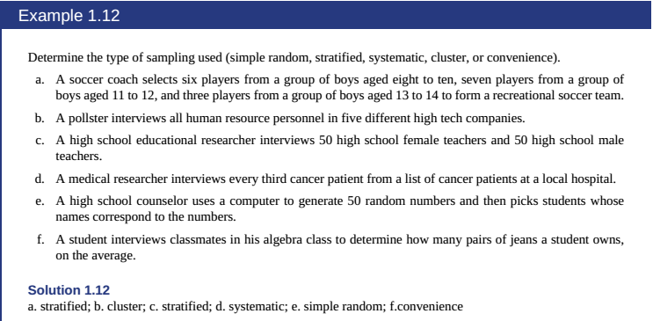

Example 1.13 – Non-Codable (Reason: Theoretical example with the purpose of proving a concept)

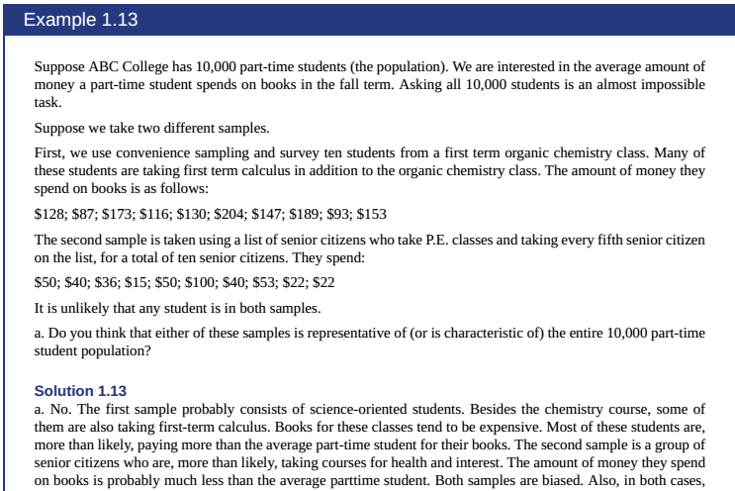

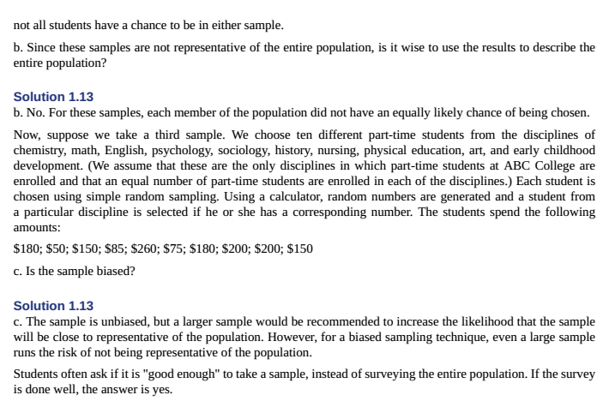

Example 1.14 – Codable

Example 1.15 – Codable

Example 1.16 – Codable

Example 1.17 – Codable

Example 1.18 – Codable

Example 1.19 – Non-Codable (Reason: Theoretical example with the purpose of proving a concept)

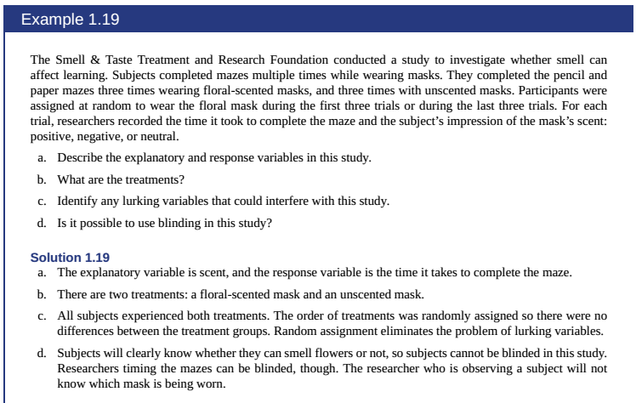

Chapter 2: DISCRIPTIVE STATISTICS

Example 2.1 – Codable

Example 2.2 – Codable

Example 2.3 – Codable

Example 2.4 – Codable

Example 2.5 – Codable

Example 2.6 – Codable

Example 2.7 – Codable

Example 2.8 – Codable

Example 2.9 – Codable

Example 2.10 – Codable

Example 2.11 – Codable

Example 2.12 – Codable

Example 2.13 – Codable

Example 2.14 – Codable

Example 2.15 – Codable

Example 2.16 – Codable

Example 2.17 – Codable

Example 2.18 – Codable

Example 2.19 – Codable

Example 2.20 – Non-Codable (Reason: Theoretical example with the purpose of proving a concept)

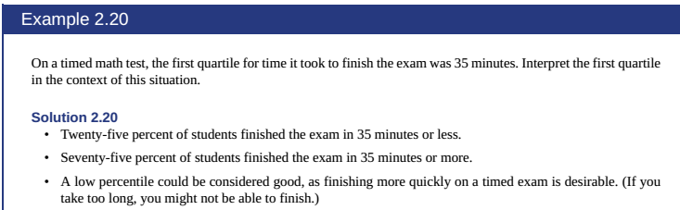

Example 2.21 – Non-Codable (Reason: Theoretical example with the purpose of proving a concept)

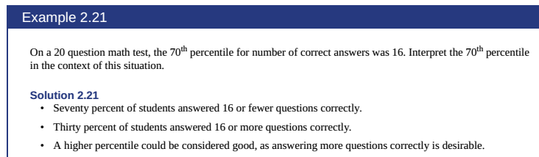

Example 2.22 – Non-Codable (Reason: Theoretical example with the purpose of proving a concept)

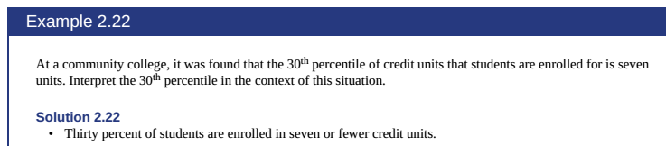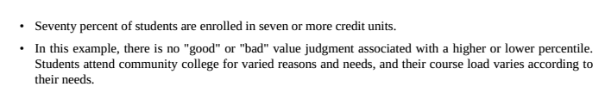

Example 2.23 – Non-Codable (Reason: Theoretical example with the purpose of proving a concept)

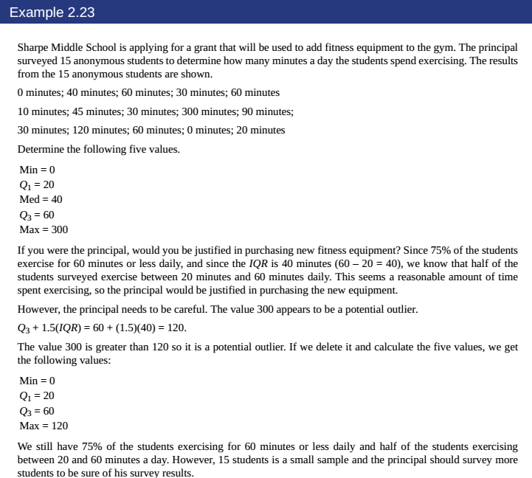

Example 2.24 – Codable

Example 2.25 – Codable

Example 2.26 – Codable

Example 2.27 – Non-Codable (Reason: Theoretical example with the purpose of proving a concept)

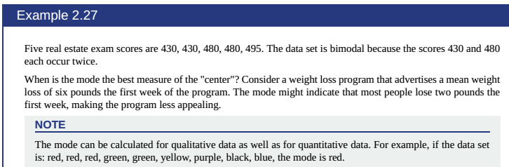

Example 2.28 – Codable

Example 2.29 – Codable

Example 2.30 – Codable

Example 2.31 – Codable

Example 2.32 – Codable

Chapter 3: Probability Topics

Example 3.1 – Codable

Example 3.2 – Codable

Example 3.3 – Codable

Example 3.4 – Non-Codable (Reason: Theoretical example with the purpose of proving a concept)

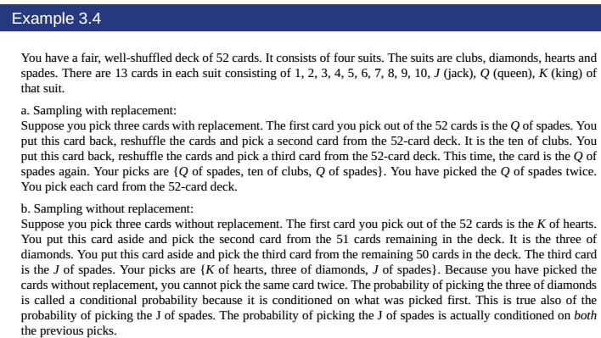

Example 3.5 – Non-Codable (Reason: Theoretical example with the purpose of proving a concept)

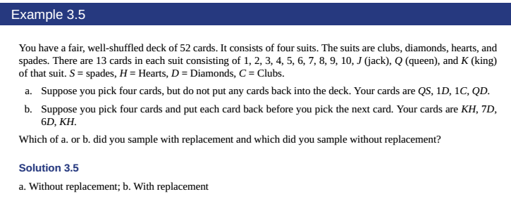

Example 3.6 – Non-Codable (Reason: Theoretical example with the purpose of proving a concept)

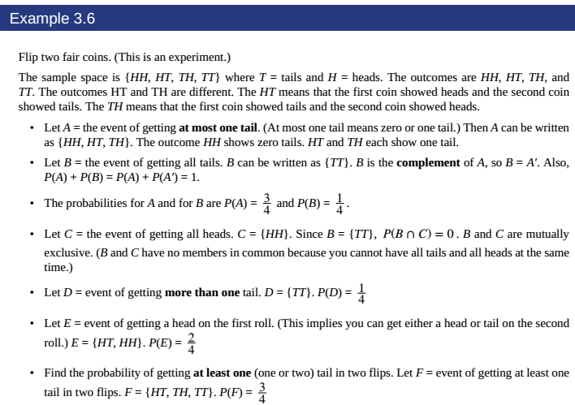

Example 3.7 – Non-Codable (Reason: Theoretical example with the purpose of proving a concept)

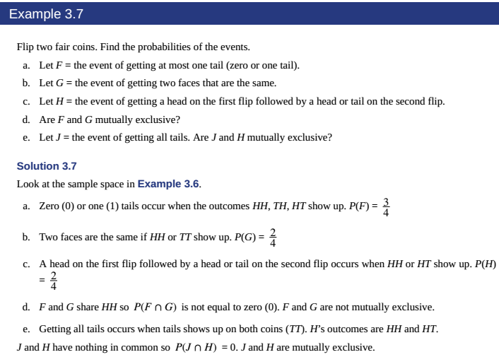

Example 3.8 – Non-Codable (Reason: Theoretical example with the purpose of proving a concept)

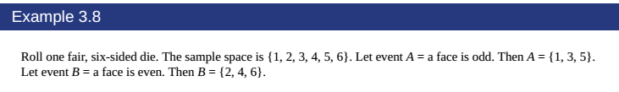

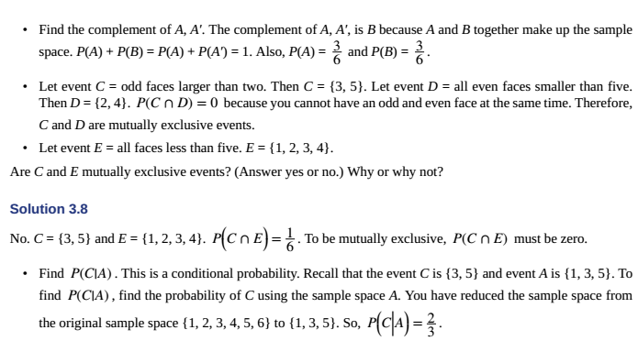

Example 3.9 – Codable

Example 3.10 – Codable

Example 3.11 – Non-Codable (Reason: Theoretical example with the purpose of proving a concept)

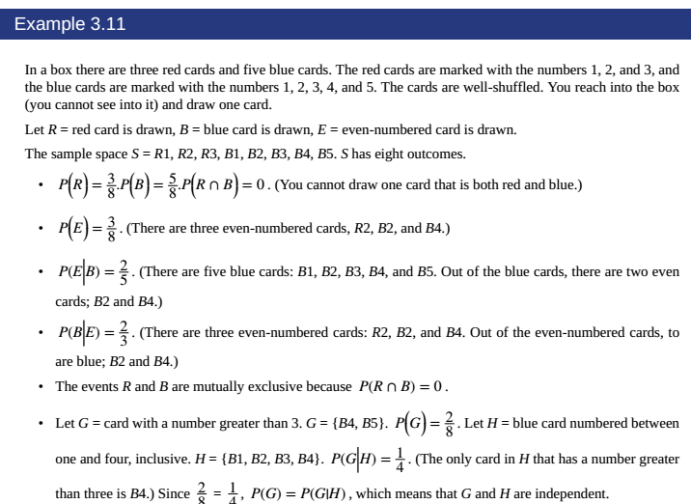

Example 3.12 – Codable

Example 3.13 – Non-Codable (Reason: Theoretical example with the purpose of proving a concept)

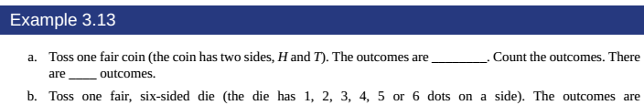

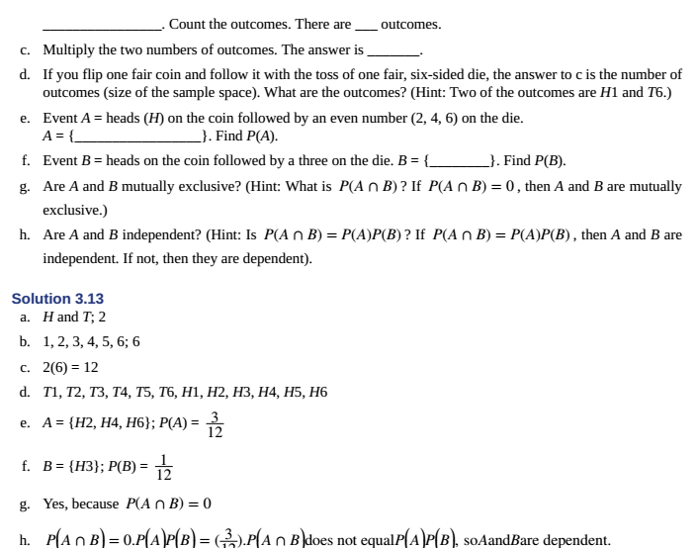

Example 3.14 – Codable

Example 3.15 – Codable

Example 3.16 – Codable

Example 3.17 – Codable

Example 3.18 – Codable

Example 3.19 – Codable

Example 3.20 – Codable

Example 3.21 – Codable – sub division c- not codable

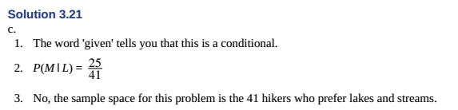

Example 3.22 – Error in question

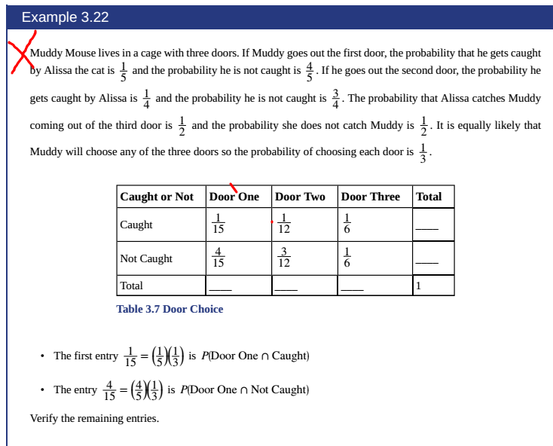

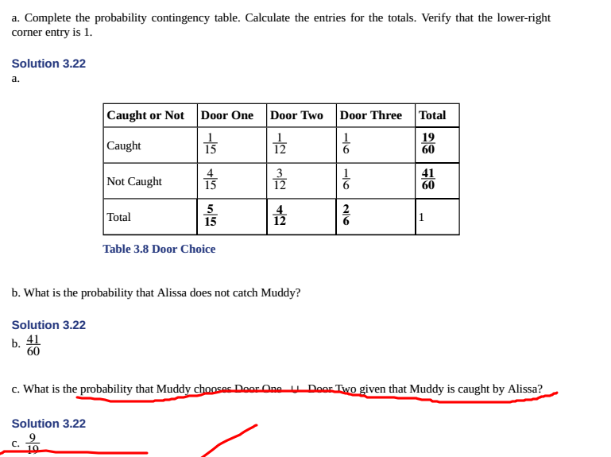

Example 3.23 – Codable

Example 3.24 – Non-Codable (Reason: Theoretical example with the purpose of proving a concept)

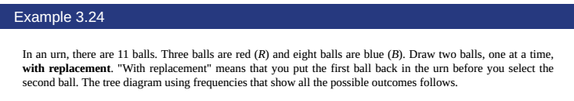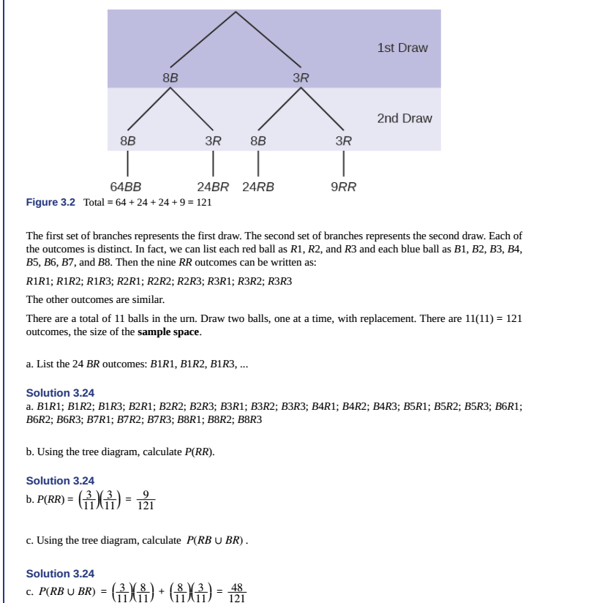

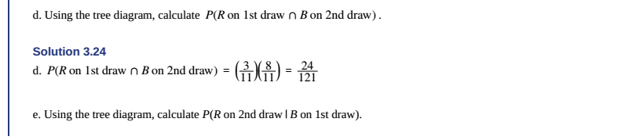

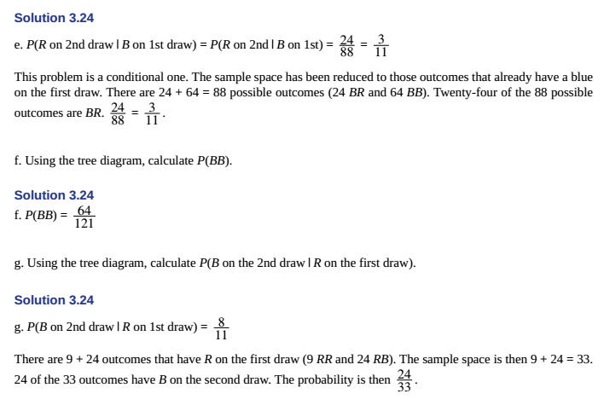

Example 3.25 – Non-Codable (Reason: Theoretical example with the purpose of proving a concept)

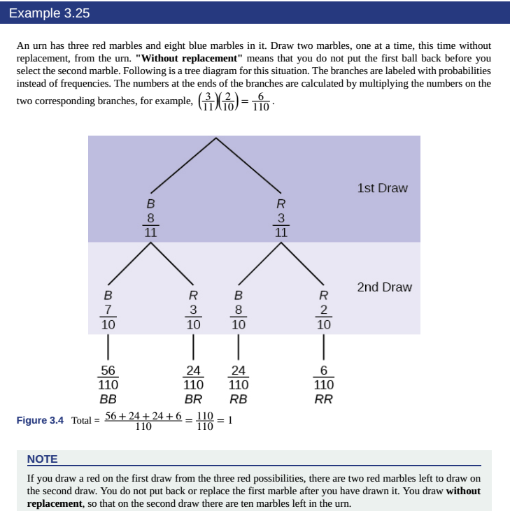

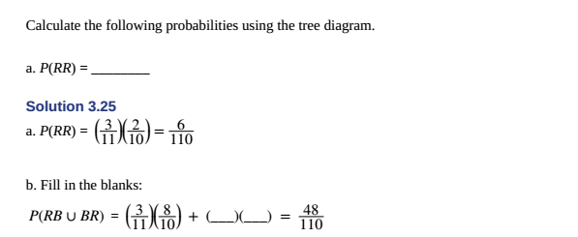

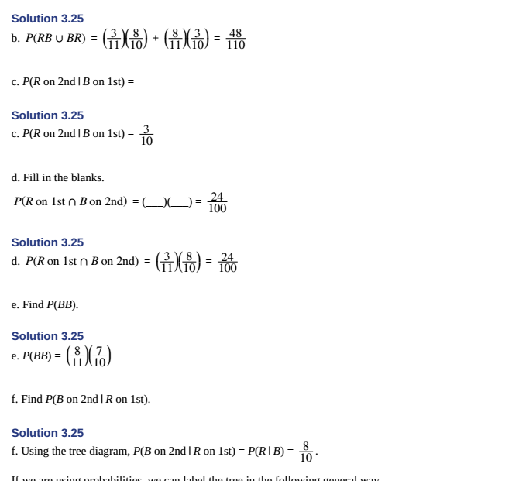

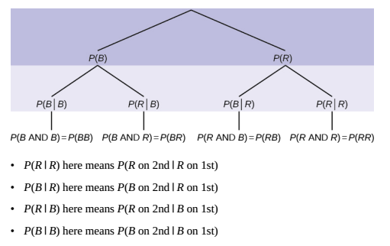

Example 3.26 – Non-Codable (Reason: Theoretical example with the purpose of proving a concept)

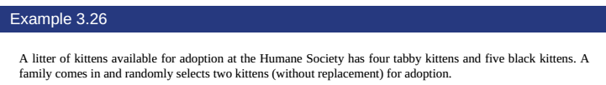

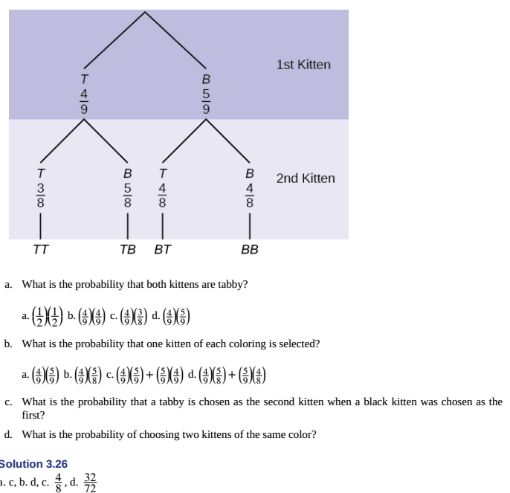

Example 3.27 – Non-Codable (Reason: Theoretical example with the purpose of proving a concept)

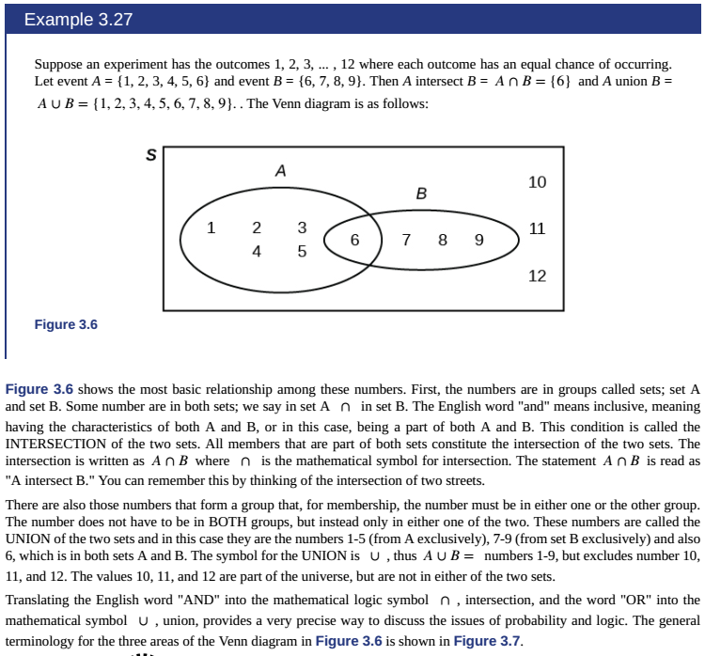

Example 3.28 – Non-Codable (Reason: Theoretical example with the purpose of proving a concept)

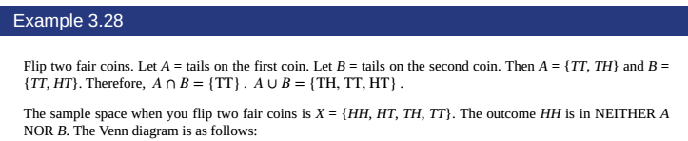

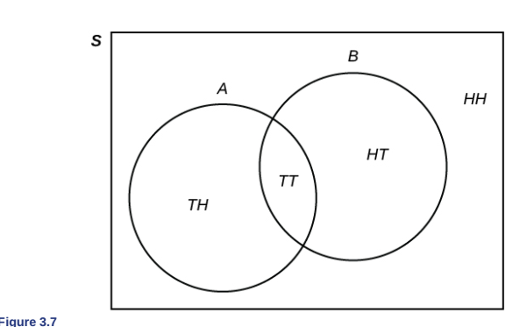

Example 3.29 – Non-Codable (Reason: Theoretical example with the purpose of proving a concept)

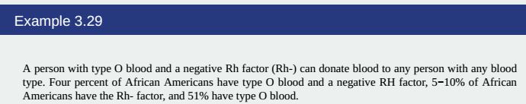

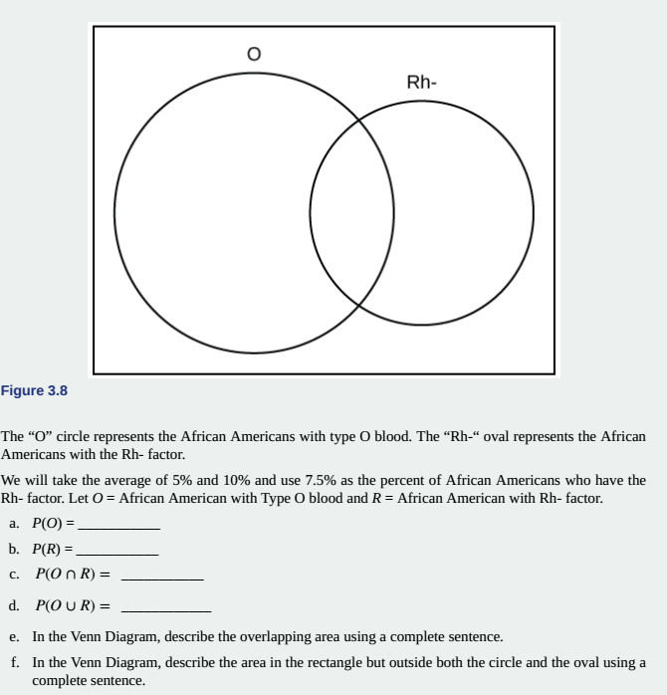Example 3.30 – Non-Codable (Reason: Theoretical example with the purpose of proving a concept)

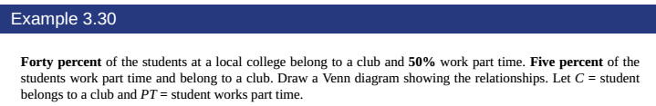

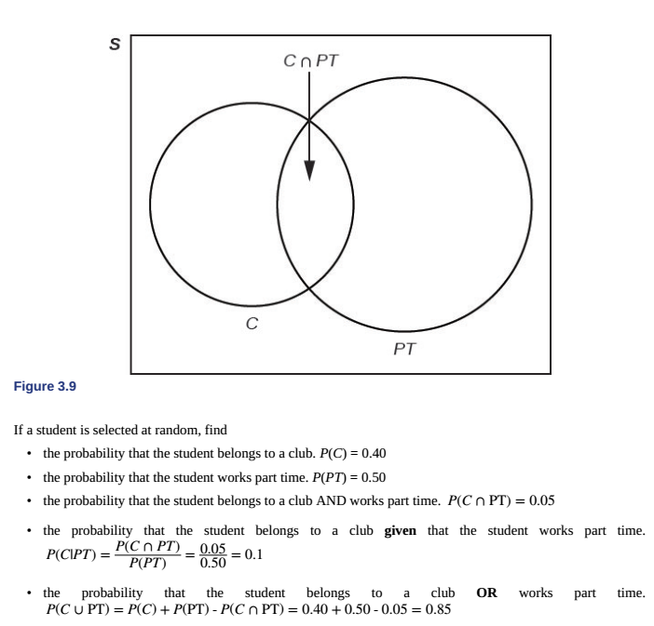



Example 3.31 – Non-Codable (Reason: Theoretical example with the purpose of proving a concept)

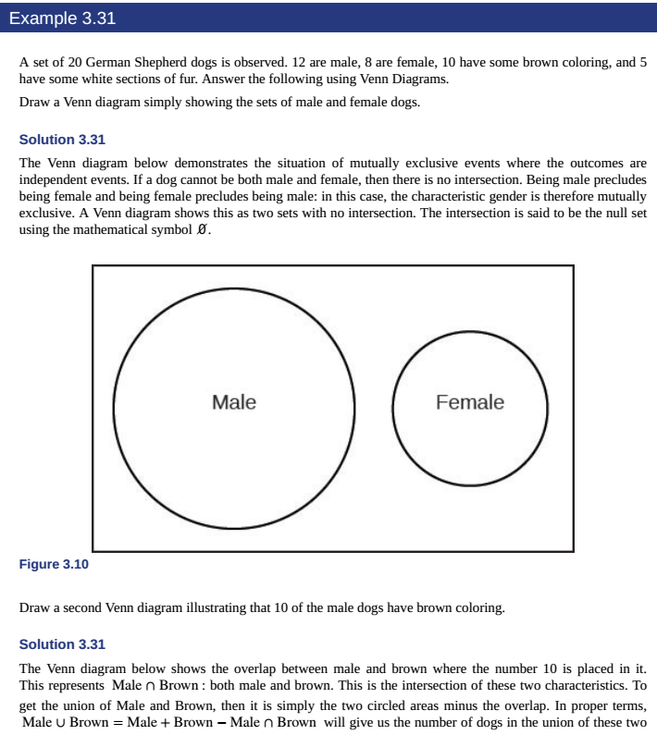

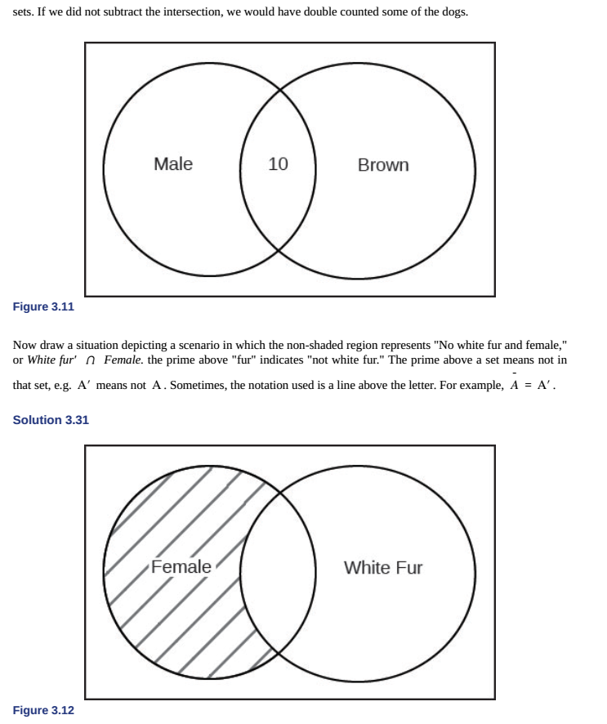

Example 3.32 – Non-Codable (Reason: Theoretical example with the purpose of proving a concept)

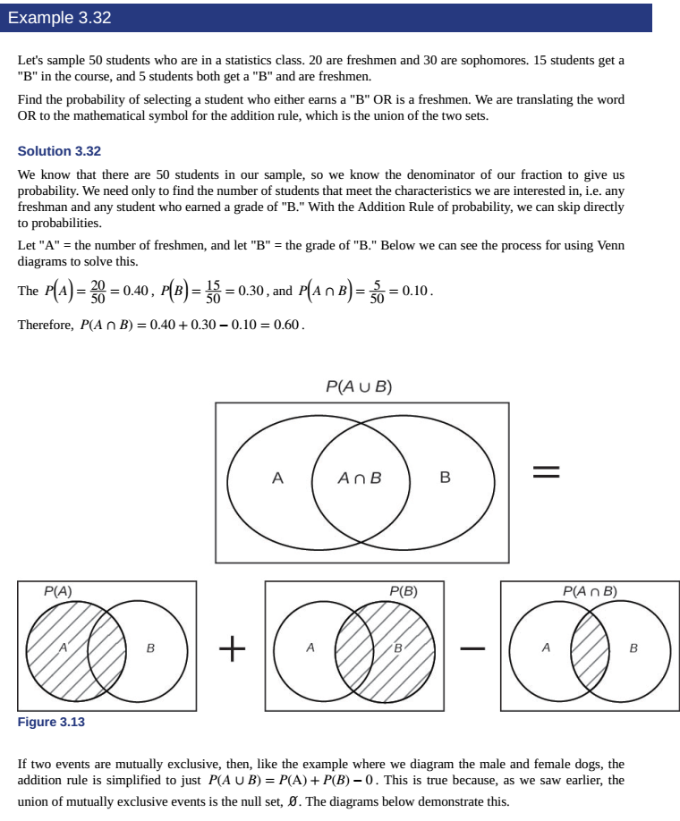

Example 3.33 –Codable

Chapter 4: Discrete Random Variables

Example 4.1 – Codable

Example 4.2 – Non-Codable (Reason: Theoretical example with the purpose of proving a concept)

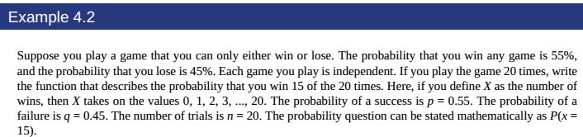

Example 4.3 – Non-Codable (Reason: Theoretical example with the purpose of proving a concept)

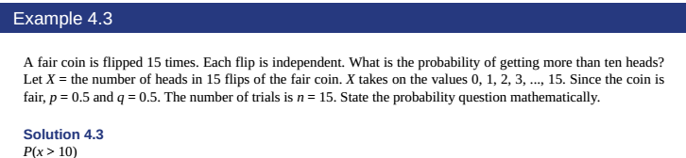

Example 4.4 – Non-Codable (Reason: Theoretical example with the purpose of proving a concept)

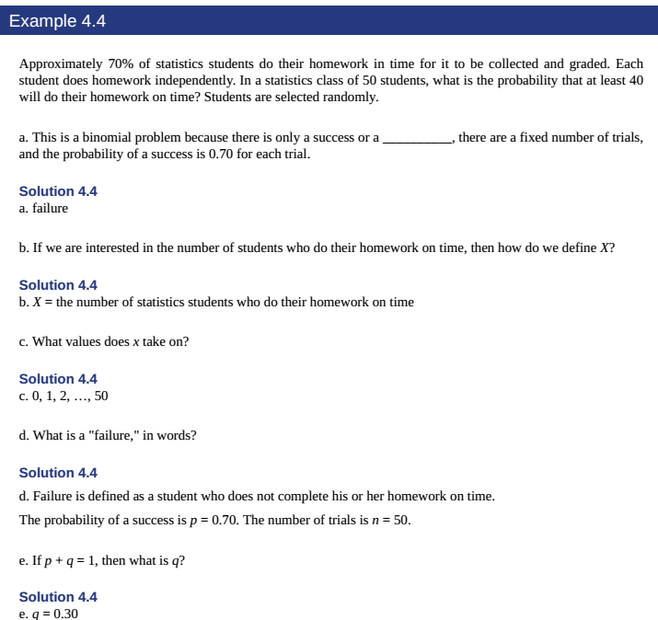

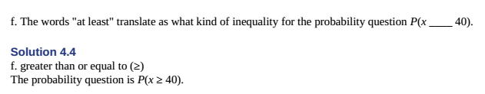

Example 4.5 – Non-Codable (Reason: Theoretical example with the purpose of proving a concept)

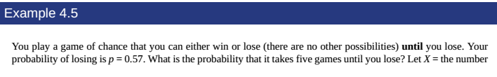Example 4.6 – Non-Codable (Reason: Theoretical example with the purpose of proving a concept)

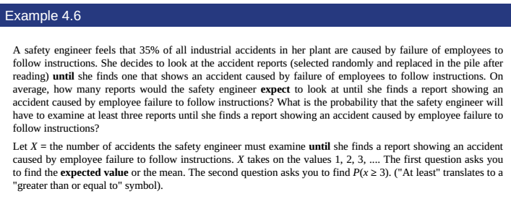

Example 4.7 – Non-Codable (Reason: Theoretical example with the purpose of proving a concept)

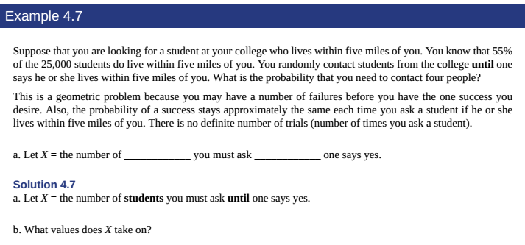

Example 4.8 – Codable

Example 4.9 – Codable

Example 4.10 – Codable

Example 4.11 – Codable

Example 4.12 – Non-Codable (Reason: Theoretical example with the purpose of proving a concept)

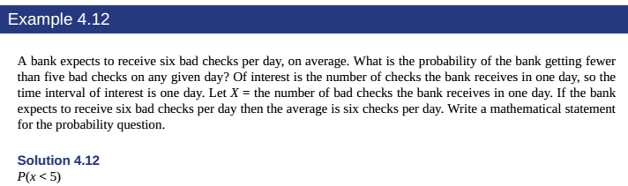

Example 4.13 – Non-Codable (Reason: Theoretical example with the purpose of proving a concept)

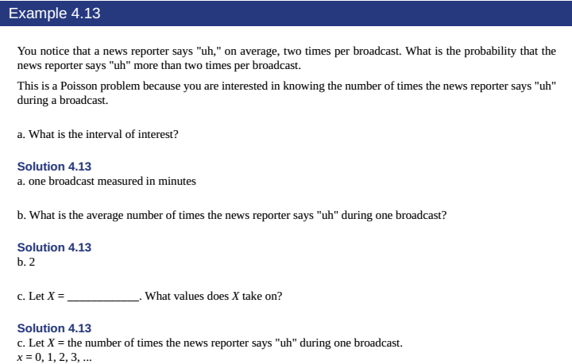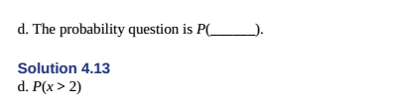

Example 4.14 – Codable

Example 4.15 – Codable

Example 4.16 – Codable

Example 4.17 – Codable

Example 4.18 – Codable

Chapter 5: Continuous Random variables

Example 5.1 – Codable

Example 5.2 – Codable

Example 5.3 – Codable

Example 5.4 – Codable

Example 5.5 – Codable

Example 5.6 – Codable

Example 5.7 – Codable

Chapter 6: The Normal Distribution

Example 6.1 – Codable

Example 6.2 – Non-Codable (Reason: Theoretical example with the purpose of proving a concept)

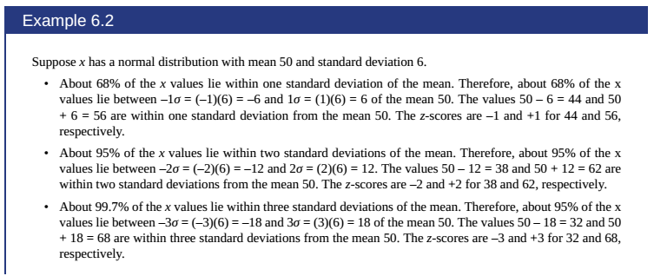

Example 6.3 – Codable

Example 6.4 – Codable

Example 6.5 – Codable

Example 6.6 – Codable

Example 6.7 – Non-Codable (Reason: Theoretical example with the purpose of proving a concept)

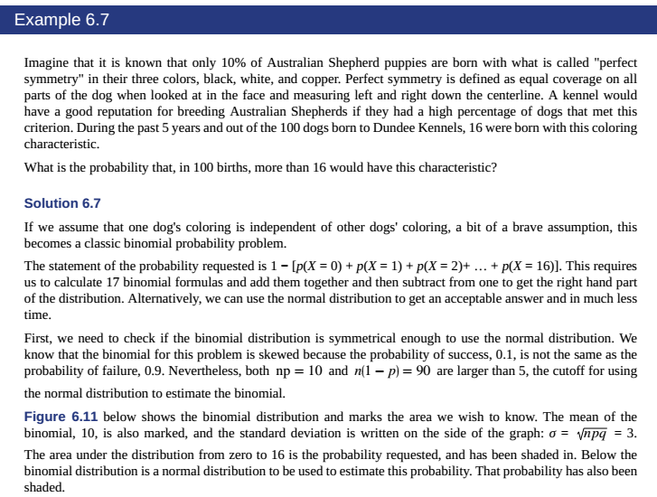

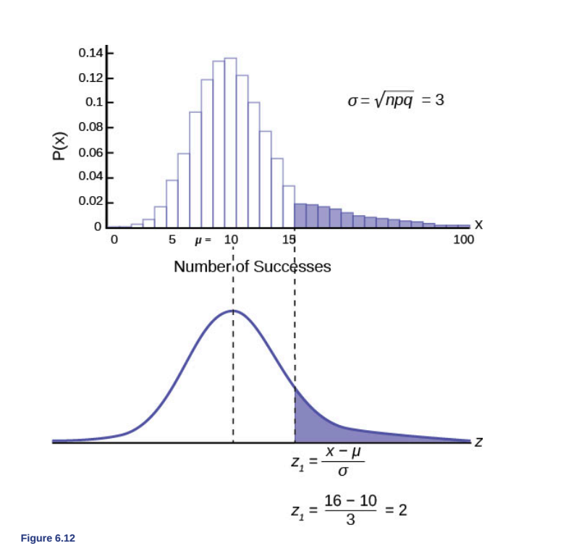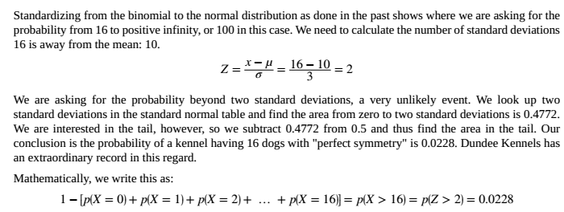

Chapter 7: The Central Limit Theorem

Example 7.1 – Codable

Example 7.2 – Codable

Chapter 8: Confidence Intervals

Example 8.1 – Codable

Example 8.2 – Codable

Example 8.3 – Codable

Example 8.4 – Codable

Example 8.5 – Codable

Example 8.6 – Codable

Example 8.7 – Codable

Example 8.8 – Codable

Example 8.9 – Codable

Chapter 9: Hypothesis Testing with one sample

Example 9.1 – Non-Codable (Reason: Theoretical example with the purpose of proving a concept)

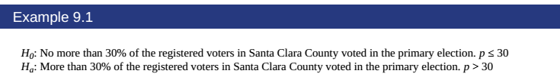

Example 9.2 – Non-Codable (Reason: Theoretical example with the purpose of proving a concept)

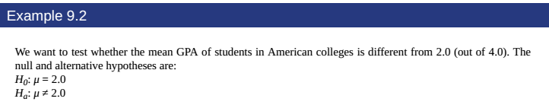

Example 9.3 – Non-Codable (Reason: Theoretical example with the purpose of proving a concept)

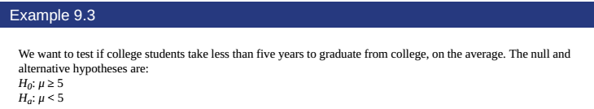

Example 9.4– Non-Codable (Reason: Theoretical example with the purpose of proving a concept)

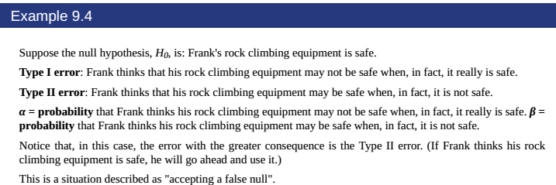

Example 9.5– Non-Codable (Reason: Theoretical example with the purpose of proving a concept)

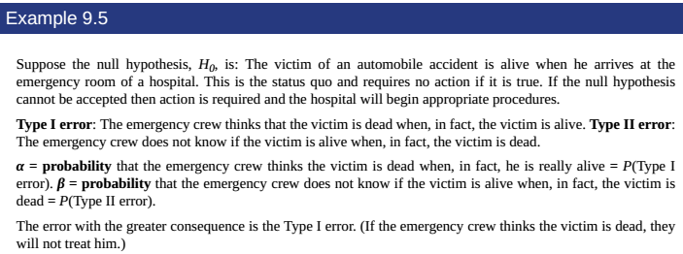

Example 9.6– Non-Codable (Reason: Theoretical example with the purpose of proving a concept)

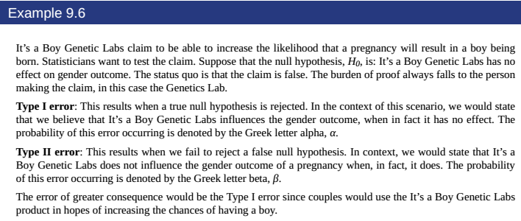

Example 9.7– Non-Codable (Reason: Theoretical example with the purpose of proving a concept)

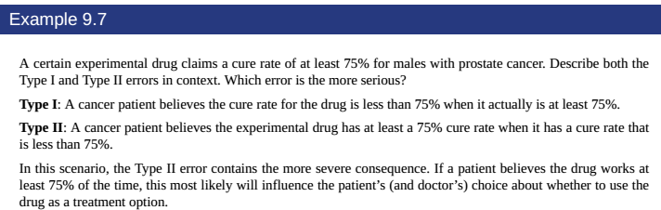

Example 9.8– Codable

Example 9.9– Codable

Example 9.10– Codable

Example 9.11– Codable

Example 9.12– Codable

Example 9.13– Codable

Example 9.14– Codable

Chapter 10: Hypothesis Testing with Two Samples

Example 10.1 – Codable

Example 10.2 – Codable

Example 10.3 – Codable

Example 10.4 – Codable

Example 10.5 – Codable

Example 10.6 – Codable

Example 10.7 – Codable

Example 10.8 – Codable

Example 10.9 – Codable

Example 10.10 – Codable

Example 10.11 – Codable

Chapter 11: The chi-square Distribution

Example 11.1 – Non-Codable (Reason: Theoretical example with the purpose of proving a concept)

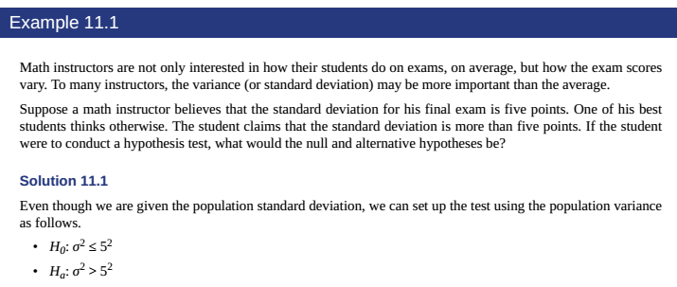

Example 11.2 – Codable

Example 11.3 – Codable

Example 11.4 – Codable

Example 11.5 – Codable

Example 11.6 – Codable

Example 11.7 – Codable

Example 11.8 – Non-Codable (Reason: Theoretical example with the purpose of proving a concept)

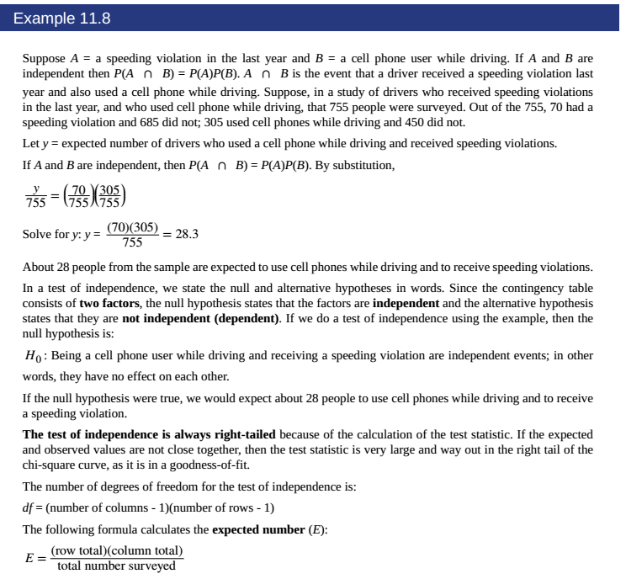

Example 11.9 – Codable

Example 11.10 – Codable

Example 11.11 – Codable

Chapter 12: F Distribution and One-way ANOVA

Example 12.1 – Codable

Example 12.2 – Codable

Example 12.3 – Codable

Example 12.4 – Codable

Example 12.5 – Codable

Chapter 13: Linear Regression and Correlation

Example 13.1 – Non-Codable (Reason: Theoretical example with the purpose of proving a concept)

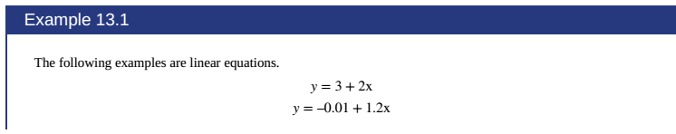

Example 13.2 – Codable

Example 13.3 – Non-Codable (Reason: Theoretical example with the purpose of proving a concept)

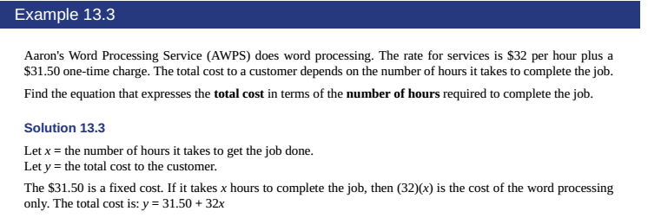

Example 13.4 – Non-Codable (Reason: Theoretical example with the purpose of proving a concept)

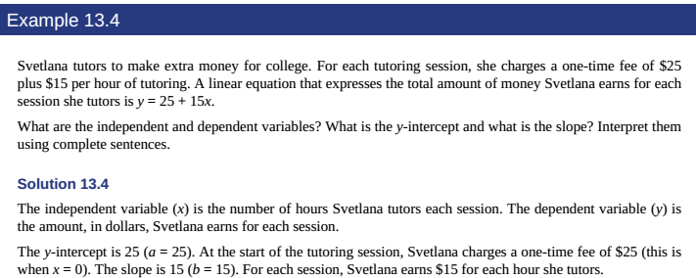Example 13.5 – Codable

Example 13.6 – Codable